## 

## 

## 

## **Hardware Design Lab Report**

BCSE - UG II - 2019 - 2020

Jadavpur University

**Batch :** 1 ,  **Group :** 6

Pritthijit Nath Rahul Shaikh Titir Adhikary Soumalya Kundu

001810501028 00181050130 001810501031 001810501033

**EXPERIMENT 1**

**AIM**

Implement a variable frequency clock using 555 timer IC.

**APPARATUS REQUIRED**

1. Oscilloscope

2. Resistors

3. Capacitor

4. Connecting Wires

5. 555 timer IC

6. Bread Board

**THEORY**

**555 Timer IC**

The 555 timer chip is extremely robust and stable 8-pin device that can be operated either as a very accurate Monostable, Bistable or Astable Multivibrator to produce a variety of applications such as one-shot or delay timers, pulse generation, LED and lamp flashers, alarms and tone generation, logic clocks, frequency division, power supplies and converters etc, in fact any circuit that requires some form of time control.

The 555 timer is operated primarily in two different modes :

1. **Astable (free-running) mode** – the 555 can operate as an electronic oscillator. Uses include LED and lamp flashers, pulse generation, logic clocks, tone generation, security alarms, pulse position modulation and so on. The 555 can be used as a simple ADC, converting an analog value to a pulse length (e.g., selecting a thermistor as timing resistor allows the use of the 555 in a temperature sensor and the period of the output pulse is determined by the temperature). The use of a microprocessor-based circuit can then convert the pulse period to temperature, linearize it and even provide calibration means.

Fig 1. Schematic of a 555 timer in astable mode.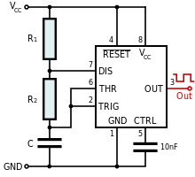

The frequency of the pulse (in astable mode) is given by :



1. **Monostable (one-shot) mode** – in this mode, the 555 functions as a "one-shot" pulse generator. Applications include timers, missing pulse detection, bounce-free switches, touch switches, frequency divider, capacitance measurement, pulse-width modulation (PWM), and so on.

Fig 1. Schematic of a 555 timer in monostable mode.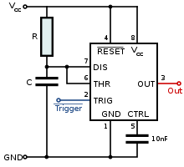

The time period of the pulse (in monostable mode) is given by :



**Circuit Diagram**

**using Multisim**

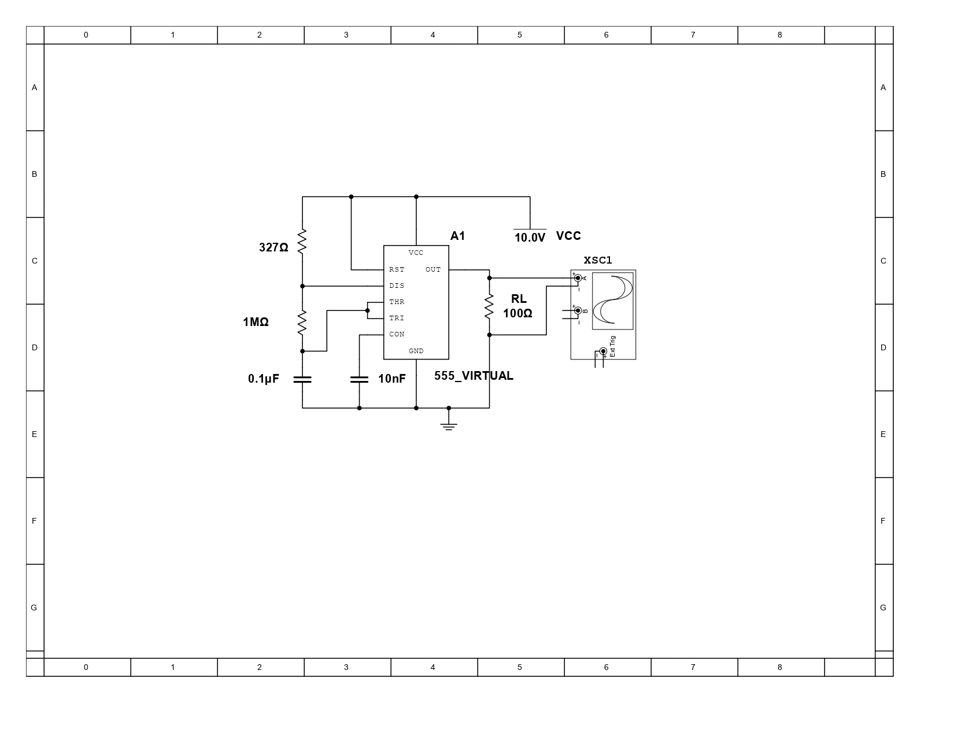

**EXPERIMENT 2**

**AIM**

Design a 2 digit BCD up/down counter using decade counter chips like 74190.

**APPARATUS REQUIRED**

1. Bread Board

2. Connecting Wires

3. IC 74190 (Decade Counter)

4. IC 7447

5. Seven Segment Display

6. Resistors

7. Clock Pulse Generator

**THEORY**

**BCD Counter**

A decade counter has four flip-flops and 16 potential states, of which only 10 are used and if we connected a series of counters together we could count to 100 or 1,000 or to whatever final count number we choose.

The total number of counts that a counter can count too is called its **MODULUS**. A counter that returns to zero after **n** counts is called a **modulo-n counter**, for example a modulo-8 (MOD-8), or modulo-16 (MOD-16) counter, etc, and for an “n-bit counter”, the full range of the count is from 0 to 2n-1.

A counter which resets after ten counts with a divide-by-10 count sequence from binary 0000 (decimal “0”) through to 1001 (decimal “9”) is called a “binary-coded-decimal counter” or **BCD Counter** for short and a MOD-10 counter can be constructed using a minimum of four toggle flip-flops.

It is called a BCD counter because its ten state sequence is that of a BCD code and does not have a regular pattern, unlike a straight binary counter. Then a single stage BCD counter such as the IC74190 counts from decimal 0 to decimal 9 and is therefore capable of counting up to a maximum of nine pulses. Note also that a digital counter may count up or count down or count up and down (bidirectional) depending on an input control signal.

Binary-coded-decimal code is an **8421** code consisting of four binary digits. The 8421 designation refers to the binary weight of the four digits or bits used. For example, 23 = 8, 22 = 4, 21 = 2 and 20 = 1. The main advantage of BCD code is that it allows for the easy conversion between decimal and binary forms of numbers.

Fig 1. BCD Counter State Diagram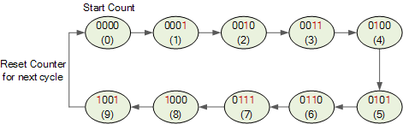

**IC 74190**

The IC 74190 is a MOD-10 decade counter that outputs BCD code. The integrated circuit is a synchronous Up /Down BCD Decade Counter. Each circuit contains four master / slave flip-flops, with internal gating and steering logic to provide individual preset, count-up and count-down operations.

The synchronous operations are provided in the IC by clocking all the flip flops simultaneously so that the outputs change coincident with each other when instructed by the steering logic. This eliminates the spikes in the output normally associated with asynchronous counters.

The outputs of the four master slave flip flops are triggered on a low to high transition of the clock input if the enable input is low. A high at the enable inhibits counting. Level changes at the enable input should be made only when the input is high. The direction of the count is determined by the level of the down/up input. When low, the counter counts up and when high, it counts down.

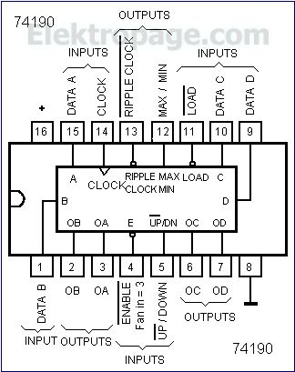

Fig 2. IC 74190 Connection Diagram

**IC 7447**

It features active low outputs designed for driving common anode LEDs directly. All of the circuits have full ripple blanking input/output controls and a lamp test input. It incorporates automatic leading and/or trailing edge, zero blanking control. Lamp test of the devices may be performed at any time when the BI/RBO node is at a high logic level. All types contain an overriding blanking input (BI) which can be used to control the lamp intensity (by pulsing) or to inhibit the outputs.

Fig 3. IC 7447 connected to a 7 Segment Display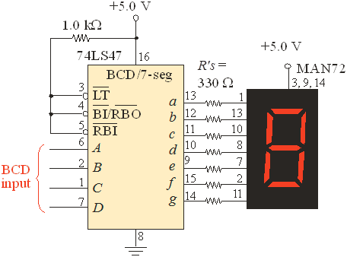

**Seven Segment Display**

It is a form of electronic display device for displaying decimal numerals that is an alternative to the more complex dot matrix displays. Seven Segment displays are widely used in digital clocks, electronic meters, basic calculators and other electronic devices that display numerical information.

Fig 4. Schematic representation of a seven segment display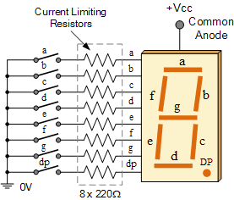

**Clock Pulse Generator**

It is usually an electronic test equipment to generate different types of electronic waveforms over a wide range of frequencies. Some of the most common waveforms produced by the function generator are the sine wave, square wave, triangular wave and saw-tooth shapes.

**PRECAUTIONS**

1. Resistances must be used to keep the displays safe.
2. Square function needs to be used as clock input.

**Circuit Diagram**

**using Multisim**

